Adityaprava Sen

CSE 2nd year

Roll-56

Assignment 1 Outputs

1a-1i Outputs:

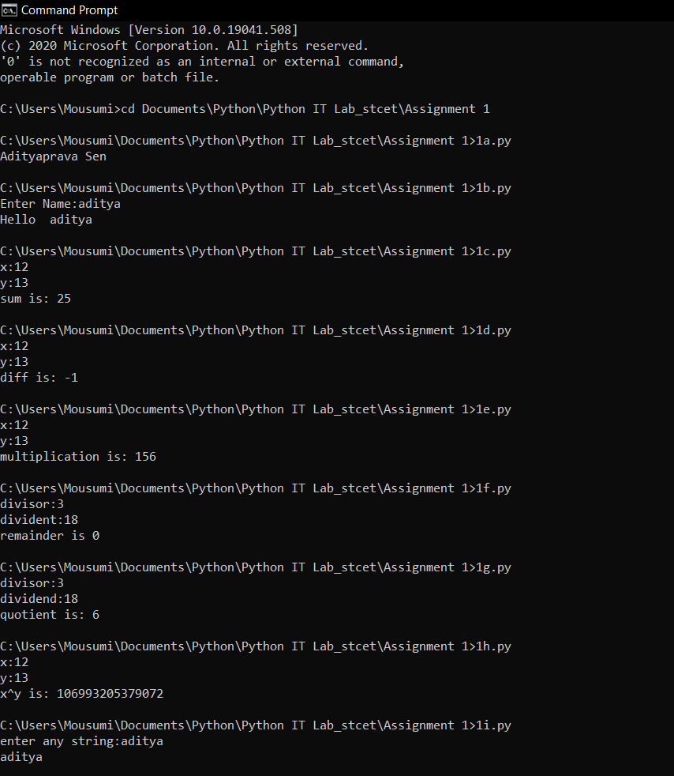

1j-3 Outputs:

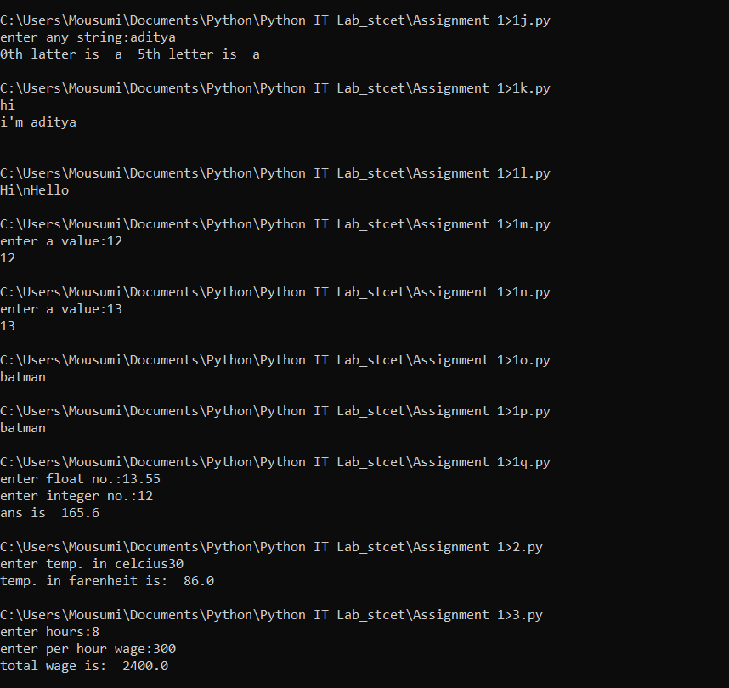

4-6 Outputs:

